Q. What fabrication patterns are compatible with the new handle set?

A. The small contemporary handle will fit industry standard center (3 hole) or offset (4 hole) fabrication patterns.

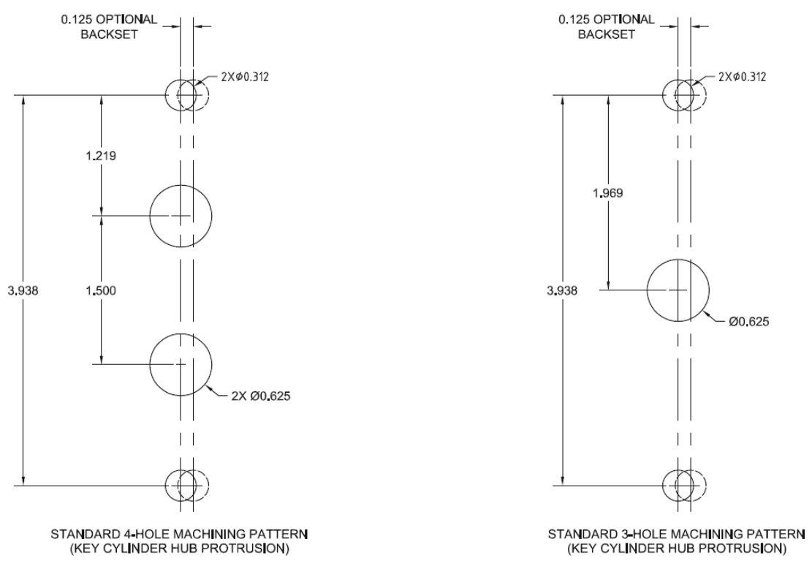

Q. Are there other handle sets in the Quanex offering that will fit the same fabrication patterns?

A. Quanex handle sets that use the same fabrication patterns include the Omega, Legacy, Arch, Allure, Olympus, Signature 40.90, and Contemporary 40.69 handle sets.

Q. What locks are compatible with the new handle set?

A. The new handle set will work with Quanex single point, dual point, Gemini II, Nexus 2-point, and Nexus 3-point locking systems.

Q. Are there manufacturing/assembly benefits to this handle set?

A. This handle presents an updated, contemporary style at a competitive price. Its single-piece construction simplifies assembly of the door panel in either the manufacturing plant or at the job site. The fabrication pattern is compatible with industry standard hole patterns, making it easy to differentiate door programs with alternative handle styles.

Q. What door materials are compatible with the handle set?

A. These handles will fit any door substrate – vinyl, wood, aluminum, steel, fiberglass, etc.

Q. What panel thickness will the standard handle set fit?

A. Each handle set has 3 sets of mounting screws to fit a range of stile thicknesses.
- Handle / Pull – 1.44 to 1.81
(shorter thickness range due to available tapping space in the exterior pull without posts that tie into the profile)
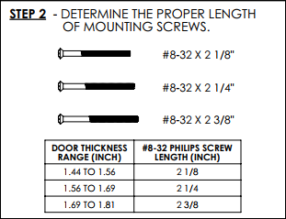
- Handle / Handle – 1-1/4 to 2-3/16
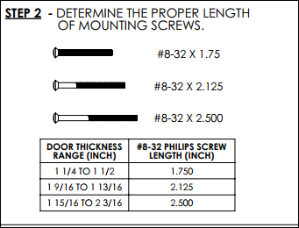

Q. What handle set colors are available?

A. Aluminum handles are available in 2 whites, beige, and gloss black. Zinc handles are available in the same colors as aluminum with the addition of matte black, faux bronze, and plated satin nickel finishes.

Q. What is the physical size of the handle?

A. The handle is 7 inches tall, 2.62 inches wide, and 1.80 inches deep. The escutcheon width is .95 inches.

Q. Do the handles have mounting posts that extend into the profile?

A. The interior handles have posts that extend into the profile. This is also true of the exterior handle. Exterior pulls mount flush to the face of the profile with no posts.

Q. Are the new contemporary handles offered with key cylinders?

A. We offer these handles in non-keyed, keyed, and dummy configurations. Key cylinder specific information is provided below:
- Schlage C type keyways
- 5 pin tumblers
- 10,000 possible key codes
- KD standard, KA cylinders are available as a separate purchase

Q. What is the carton quantity?

A. Aluminum handle sets with exterior pulls or exterior handles are packaged in carton quantities of 20. Zinc handle sets are packaged in carton quantities of 10.

Q. Are the new contemporary handles offered with gaskets?

A. The handle sets offered with exterior handles include full length closed cell foam gaskets

Q. Why are both aluminum and zinc substrates offered?

A. Cast aluminum substrate is offered to provide a lower cost alternative to zinc substrate. Despite the low weight of the product, it will provide a sturdy user interface when bolted to the door panel. Zinc performs better than aluminum from a corrosion-resistant standpoint. It is also a better substrate for plating.

Q. What can I expect for corrosion resistance in these new handle sets?

A. Corrosion resistance is dependent on substrate and finish type. Below you will find general information regarding corrosion resistance for these items.
- Powder coated aluminum – 350 hours
- Powder coated zinc – 500 hours

